Sequence Diagrams

Display Customer List

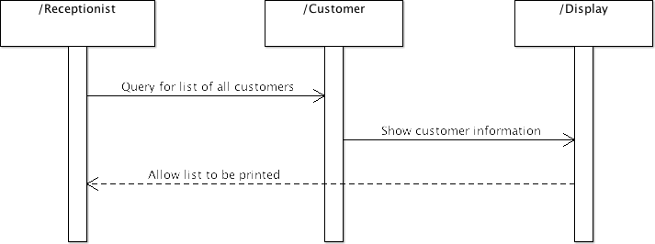

Add New Customer

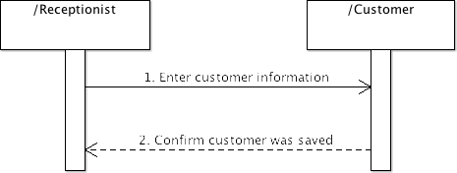

Display List of Jobs



Add New Job



Display/print list of Employees

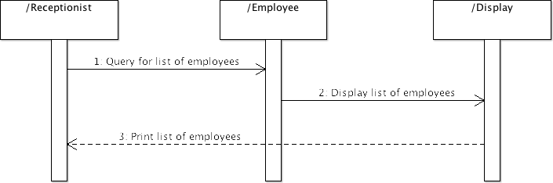

New Employee

